ELC 433-L1

Lab 5 – Digital Filter Design

Brian Worts and Chris Jenson

11/17/20



**Introduction:**

This lab aimed to use knowledge gained from the attached lecture block to gain experience in the using of advanced tools for the design of FIR and IIR filters. The most common types of filters are lowpass, high pass, and bandpass. These types can also be designed to approximate any magnitude and phase characteristic. Analog filters are harder to implements due to the impracticality of ideal components. Whereas, the frequency response of digital filters is perfectly predictable. This lab uses MATLAB to design several filters based on various specifications. Filter design tools have two main methods of design: the ‘best’ filter of a given order to match a transfer function and when given a transfer function to find the minimum order. The limiting factor in filter design is often measured in multiplier complexity. The combination of knowledge about filter design and their constraints are used to complete this lab and further the student’s understanding of the material.

**Procedure:**

This lab had the students use the Filter Designer app in MATLAB. Part 1 was to design a minimum order FIR Equiripple lowpass filter. The magnitude response was annotated. Part 2 was to design a minimum order IIR elliptical filter. The magnitude response was annotated. Part 3 was to design a Constrained Least-Pth Norm IIR filter. The magnitude response was annotated.

**Results:**

Part 1) Min Order FIR Equiripple Lowpass Filter

* Order Required: 170
* Number of Multipliers & the Multiplications per Input Sample: 171
* Magnitude Response:

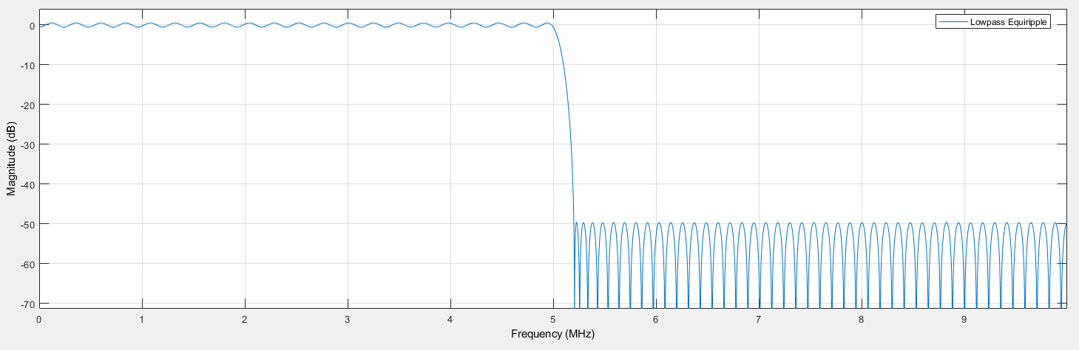

* Annotated Magnitude Response:

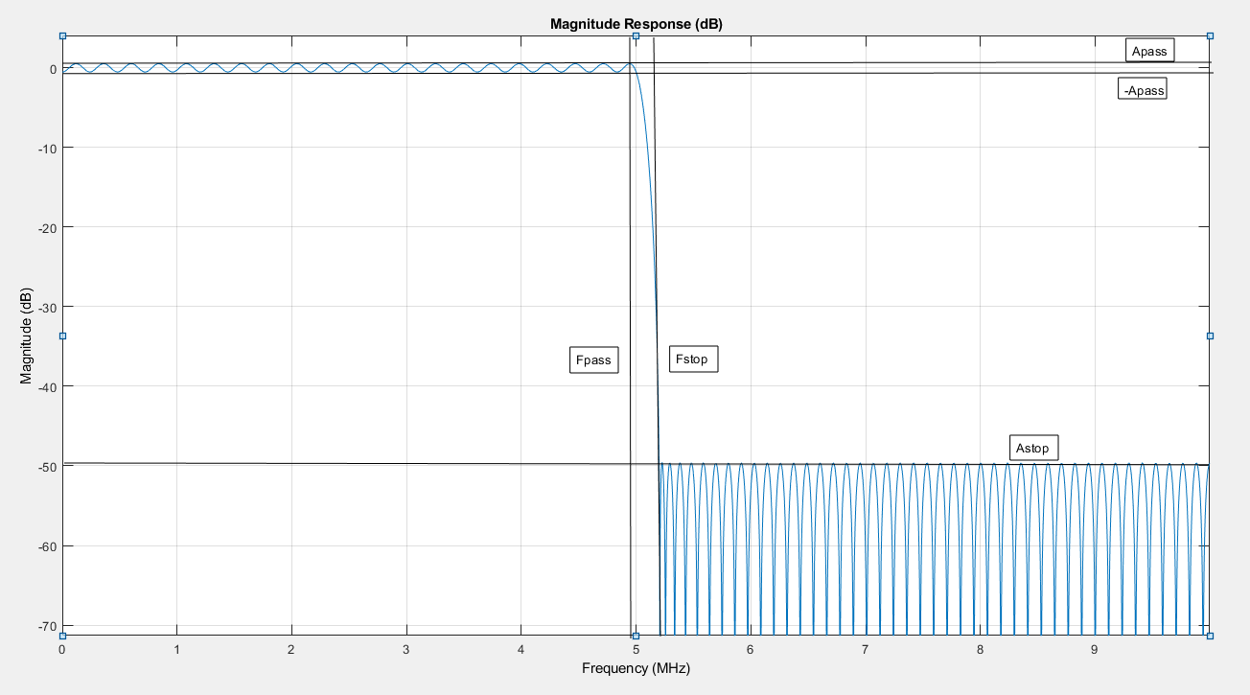

* Impulse Response:

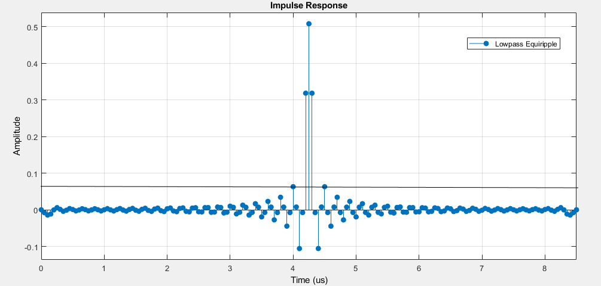

* Pole-Zero Plot:

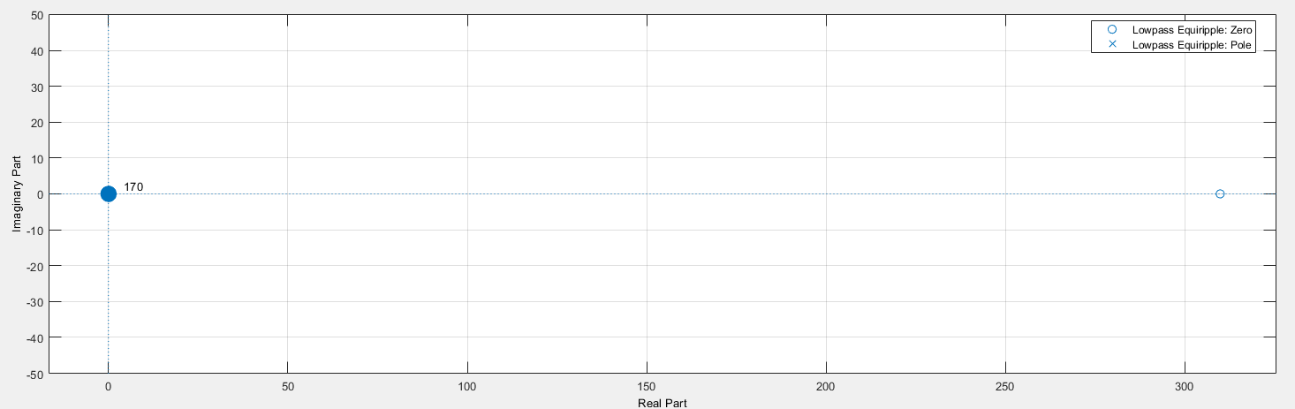

Step 2) Min Order IIR Elliptical Filter

* Order Required: 8
* Number of Multipliers & the Multiplications per Input Sample: 16
* Magnitude Response:

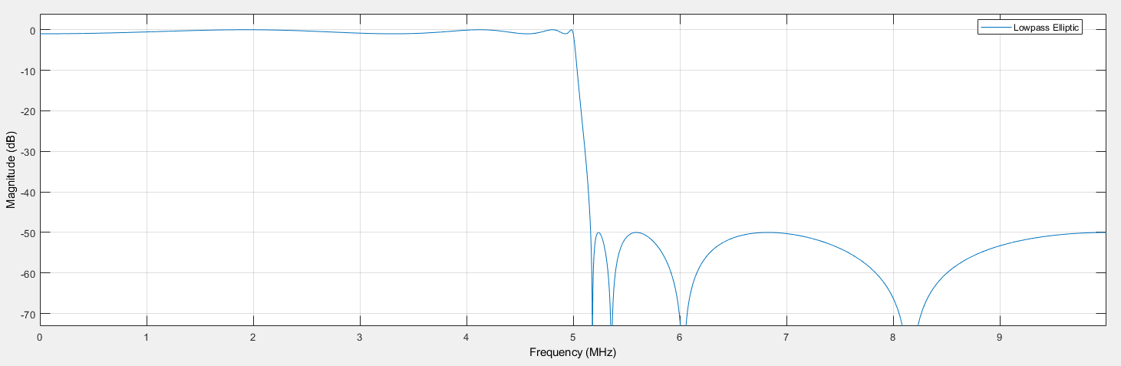

* Annotated Magnitude Response:

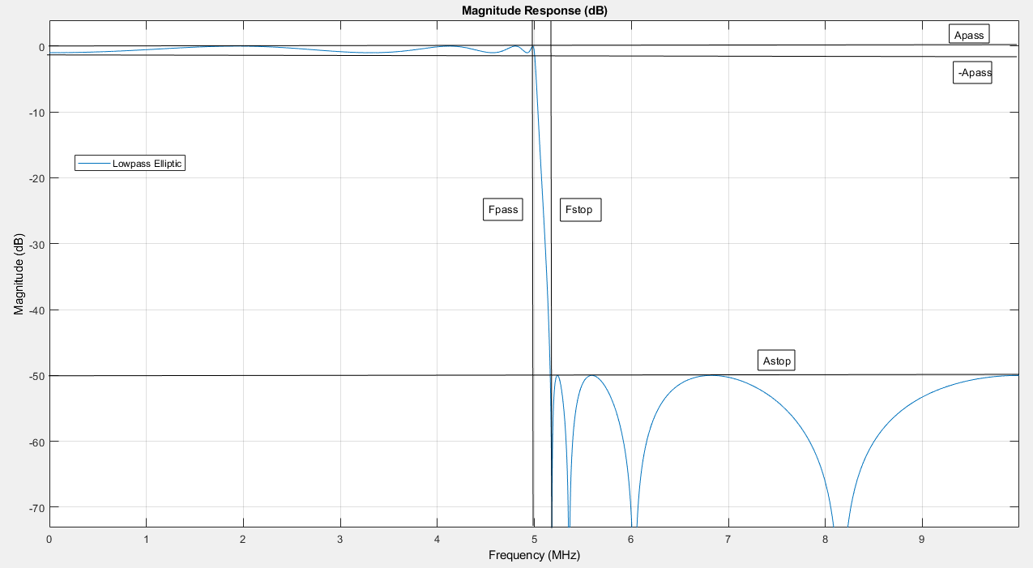

* Impulse Response:

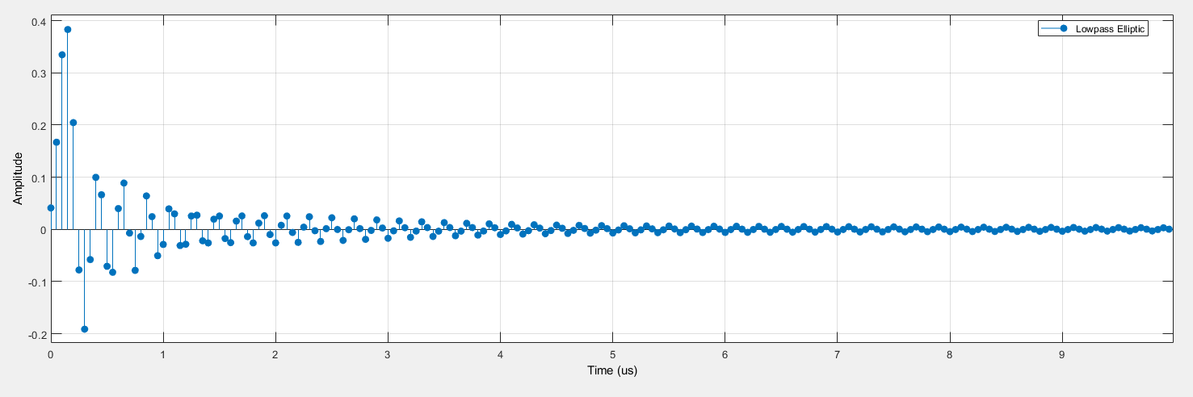

* Zero-Pole Plot:

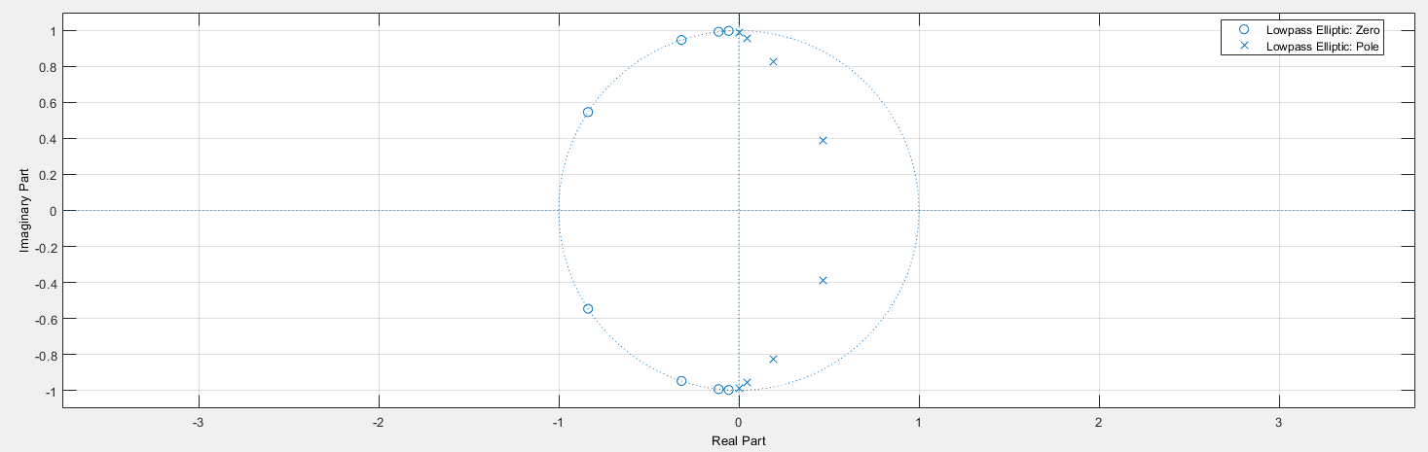

Step 3) Constrained Least-Pth Norm IIR Filter

* Order 8
* Number of Multipliers & the Multiplications per Input Sample: 17
* Magnitude Response:

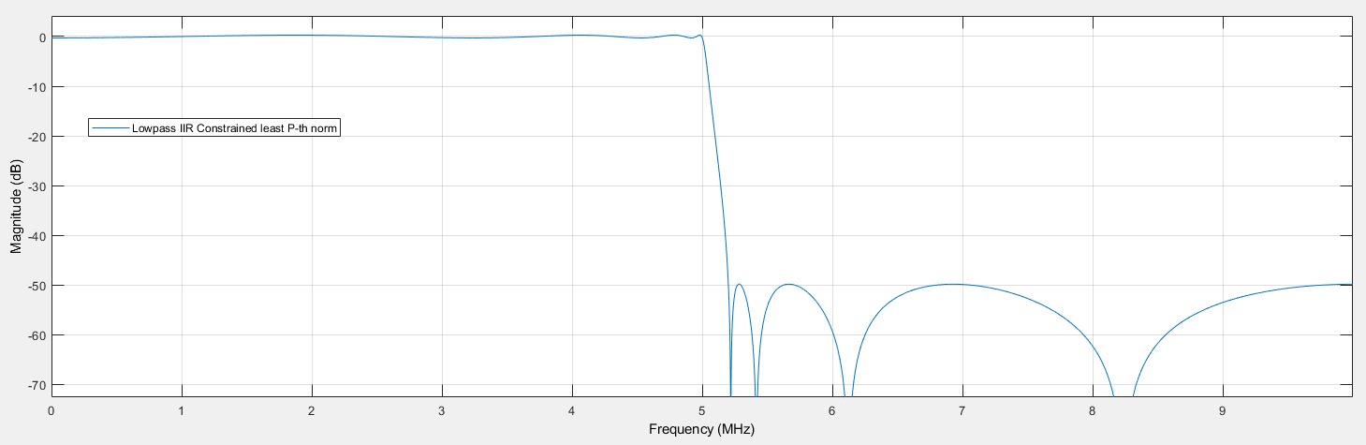

* Annotated Magnitude Response:

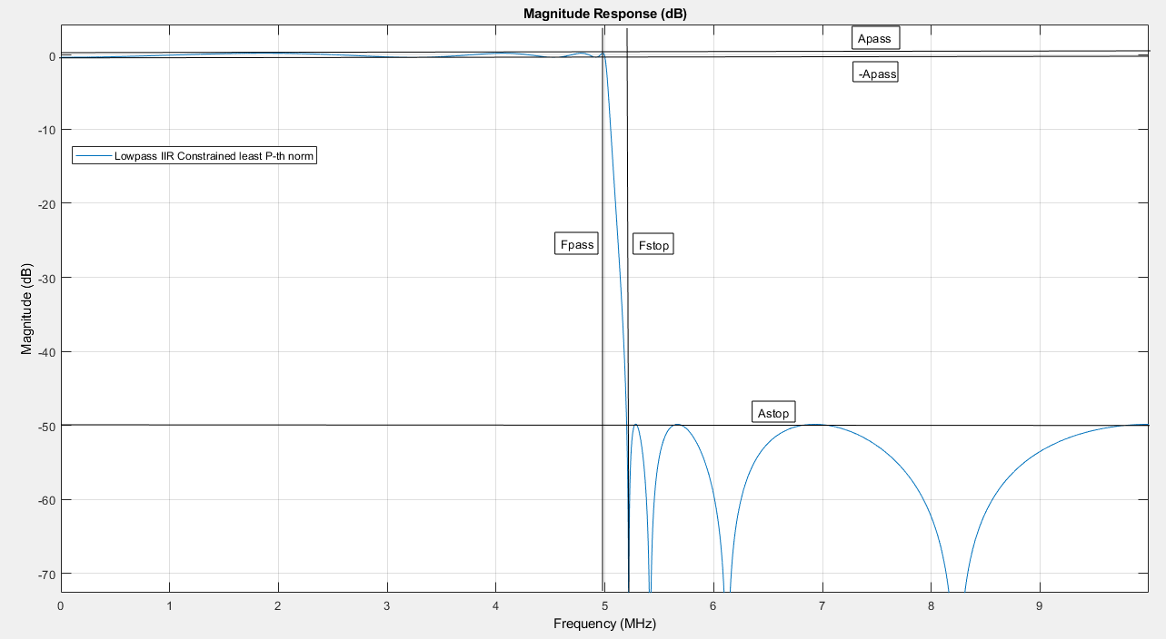

* Impulse Response:

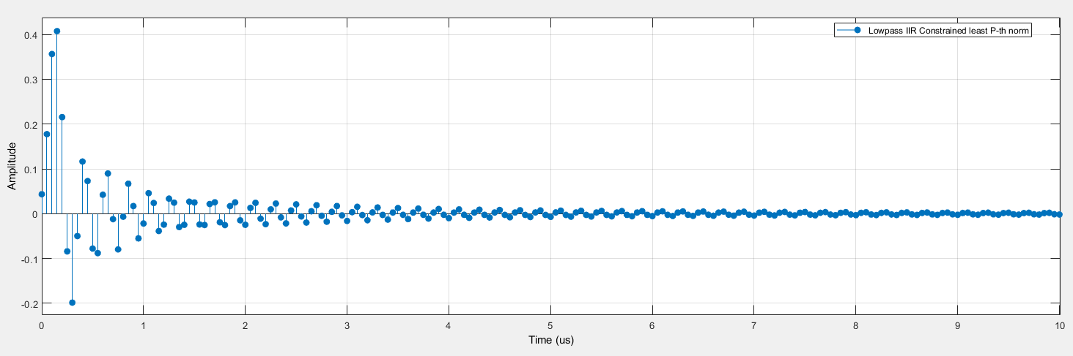

* Pole Zero Plot:

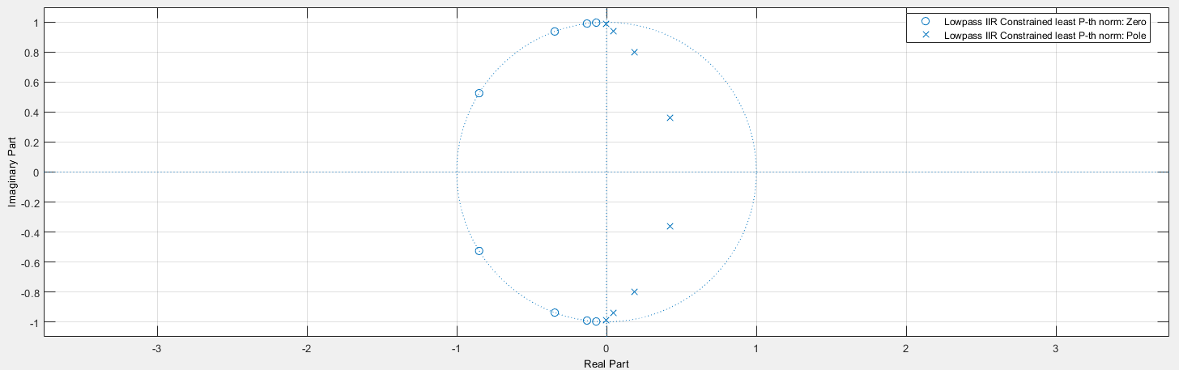

Part 4) Challenge Yourself

1. Maximum pole radius
2. Through visual analysis of the Zero-Pole Plots for parts 2 and 3, the radius for each pole in part 2 is slightly greater in magnitude than in part 3 by about 0.02. The maximum pole radii are located on the imaginary axis for both, but it is too hard to tell if there is a difference through visual inspection.
3. Passband ripple
4. The Constrained Least-Pth Norm IIR Filter has a visibly smaller ripple in the passband compared to the passband of the Min Order IIR Elliptical Filter despite both having the same order.
5. Stopband attenuation
6. There is little visible difference in the stop band attenuation other than the peaks appear to happen at slightly lower frequencies for the Min Order IIR Elliptical Filter.

|  |  |  |  |
| --- | --- | --- | --- |
| **Description** | **Expectation** | **Max Pts.** | **Pts. Deducted** |
| Introduction | Brief overview | 1 |  |
| Procedure | Brief description of procedures | 1 |  |
| Results |  |  |  |
|  | Plots | 1 |  |
|  | FIR - what is filter order required? Magn. response, annotate with filter mask. Impulse resp. Pole/zero plot. MULs? | 1 |  |
|  | Min. order IIR elliptical? Filter order required? Annotate with mask. Impulse resp. Pole/zero plot. MULs? | 1 |  |
|  | Least Pth norm IIR with same order? Annotate with mask. Impulse resp. Pole/zero plot. MULs? | 1 |  |
| Knowledge Gained |  | 3 |  |
| Who Did What |  | 1 |  |
| **Total** |  | 10 |  |

**Knowledge Gained:**

Through this lab, the team gained practical knowledge and experience with advanced tools for the design of FIR and IIR filters. It is theoretically possible to design analog filters, but due to fabrication limitations, these types of filters are extremely impractical so it is best to focus on digital filters since they have perfectly predictable responses. This lab introduced the team to the Filter Designer Tool in MATLAB, which allowed us to efficiently create and simulate filters to the desired specifications. Through the use of the filter mask tool, the team also gained experience in deriving specification values from the magnitude response of the filter such as the pass/stop band attenuation and pass/stop band ripple values. This allowed the team to better understand the differences between an FIR equiripple filter, an IIR elliptical filter, and a constrained Least-Pth Norm IIR filter. Primarily, the differences between the IIR filters come from the passband ripple values where the IIR elliptical filter has slightly less ripple than the Least-Pth Norm IIR filter. Typically, when designing a filter, a designer will need to make trade offs such as the size of ripple vs size of region between pass and stop band, but in the case of these two filters it was not visibly clear which was better in this regard.

**Who Did What:**

|  |  |  |  |  |  |
| --- | --- | --- | --- | --- | --- |
| **Student** | **Analysis** | **Development** | **Coding** | **Results** | **Writing** |
| Brian | 60 | 40 | 50 | 50 | 50 |
| Chris | 40 | 60 | 50 | 50 | 50 |